Test Case Screenshots

1. Testing the **dischargeLoan** method in Library class in the file – LibraryMockTest.java

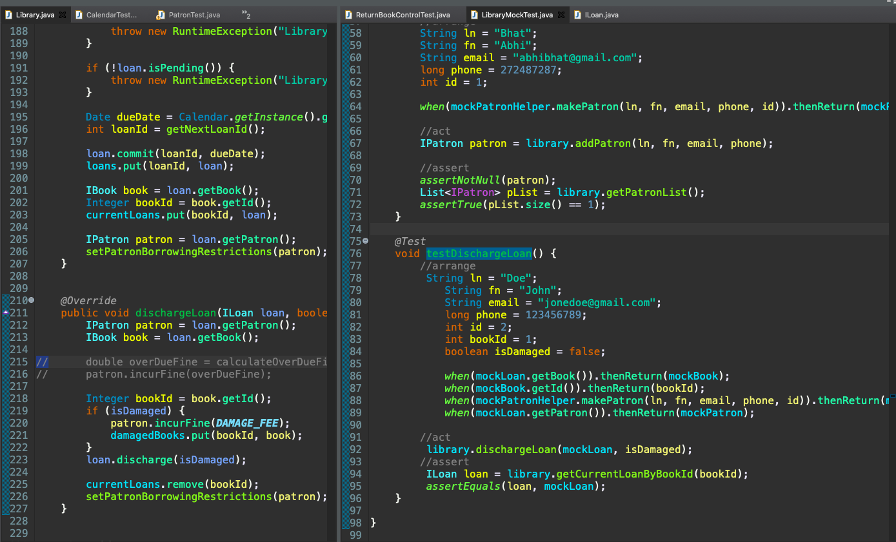

2. Testing the **bookScanned** method in Return Book Control class – ReturnBookControlTest.java

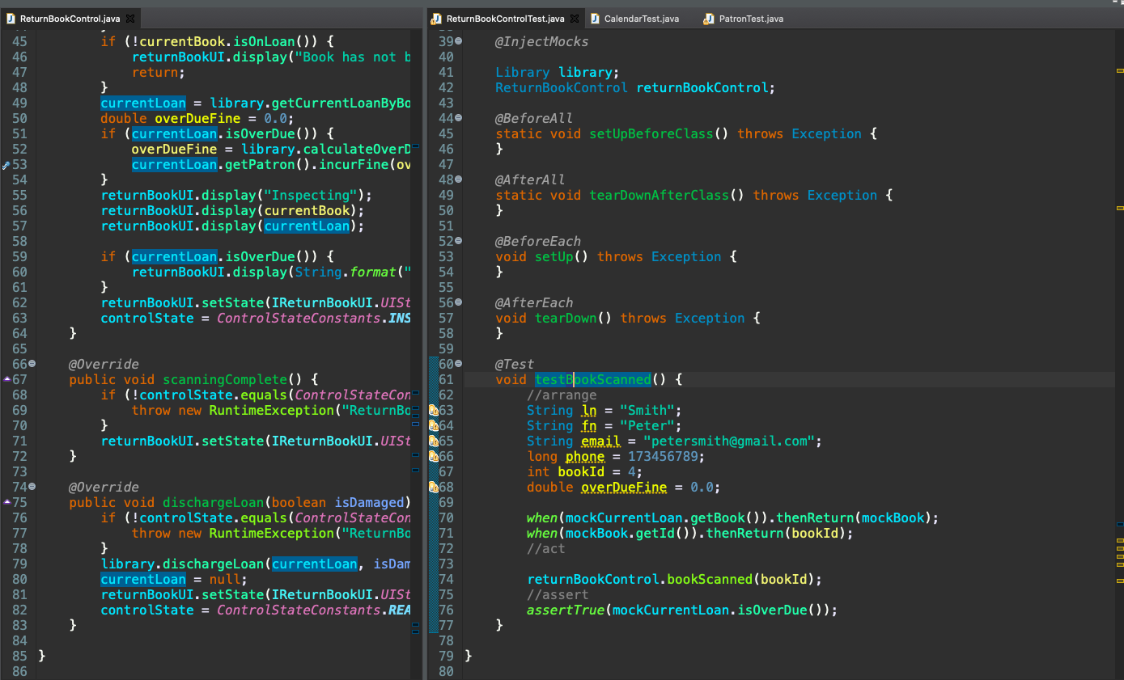

3. Tested getDaysDifference in Calendar class

